**Concept of ternary and yield**

a=7

b=1 if a>=5 else 42

print(b)

status=1

msg="Logout" if status==1 else "Login"

print(msg)

c=1 if 2+2==5 else 2

print(c)

**OUTPUT**

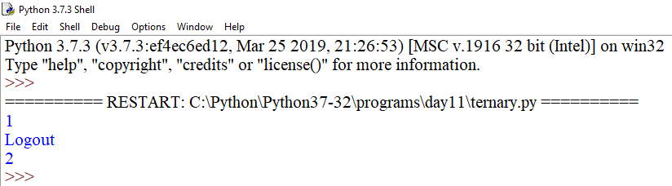

def sum_num(x):

res=0

for i in range(x+1):

res=res+i

print("i=",i,"res=",res)

yield res

ob=sum_num(10)

for i in range(11):

print(next(ob))

**OUTPUT**

